SFAC Logo 2C 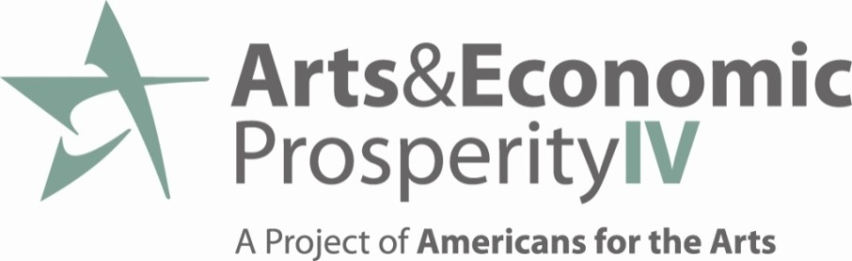

**Contact:** Nan Baker, Sioux Falls Arts Council, Executive Director [nbaker@artssiouxfalls.org](mailto:nbaker@artssiouxfalls.org)

Crane Centre @ 8th & Railroad

326 E 8th St #106A

Sioux Falls, SD 57103

Office: 605-271-6696

[www.ArtsSiouxFalls.org](http://www.ArtsSiouxFalls.org)

**Aggregate Data**

**June 19, 2012**

Total Industry Expenditures: $35,037,688

Revenue Generated to Local Government: $1,470,000

Full-time Equivalent Jobs Supported by the Arts: 1,324

Non-Profit Arts and Culture Organizations Spent: $15,932,153

Spending by Audiences in Sioux Falls: $19,105,535

Household Income generated: $30,585,000

Average Amount Spent Per Person, Per Event: $21.57

Value of In-Kind Contributions: $782,391

Total Hours Logged by Volunteers 97,860

Number of Organizations Participating in Study: 35

**This economic impact study sends a strong signal that when we support the arts, we not only enhance our quality of life, but we also invest in the economic well-being of Sioux Falls.**